Command Injection Bypass
Proof of Concept Report — HackViser Lab
Prepared by: Aakash Singh | Date: May 31, 2026

Vulnerability Information

Author | Aakash Singh
Date | May 31, 2026
Lab | Command Injection Bypass
Platform | HackViser
Vulnerability Type | OS Command Injection with Filter Bypass
Severity | Critical
CWE | CWE-78
Impact
An attacker can bypass application-level filters to inject OS commands, allowing retrieval of server hostname, DNS information, and system-level data. This can lead to full server compromise.
Reproduction Steps
Step 1: Navigate to the target endpoint that performs DNS/NSlookup-style queries.
Step 2: Identify the injection point and attempt filter bypass using applicable payload IDs.
Step 3: Inject a command separator (e.g., ; or |) to append OS commands after the legitimate input.
Step 4: Retrieve the hostname of the server using the injected command.
Step 5: Perform a DNS search on the discovered hostname to enumerate server information.
Evidence Screenshots
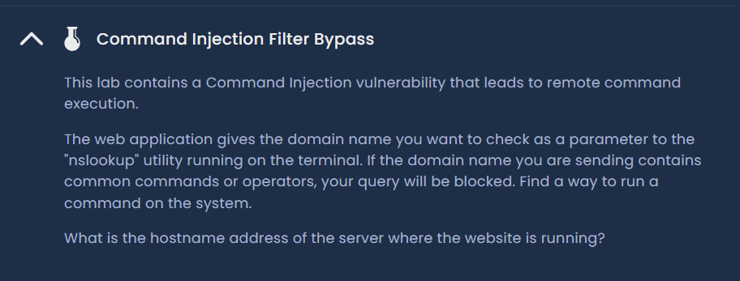
Figure 1: Target endpoint identified — initial request
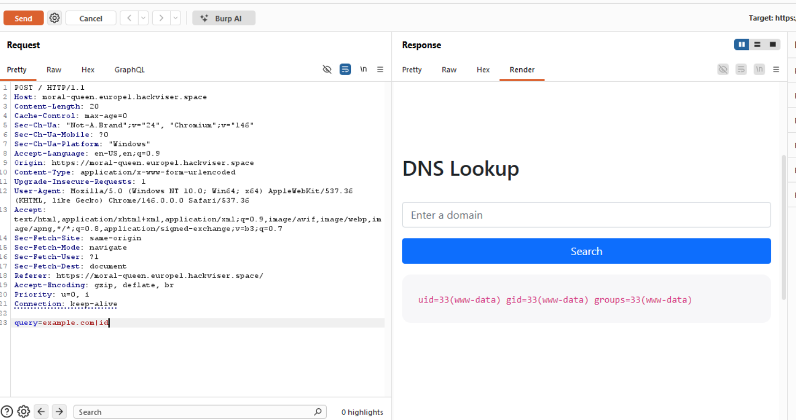
Figure 2: Filter bypass payload applied — injection point confirmed
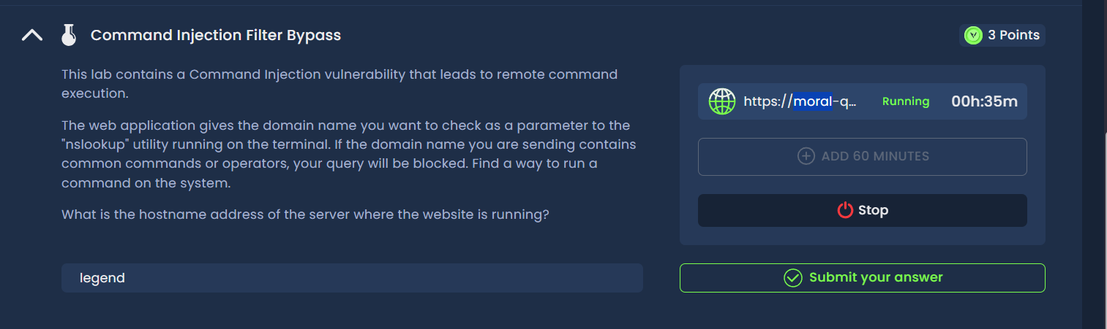
Figure 3: OS command injected — server hostname retrieved
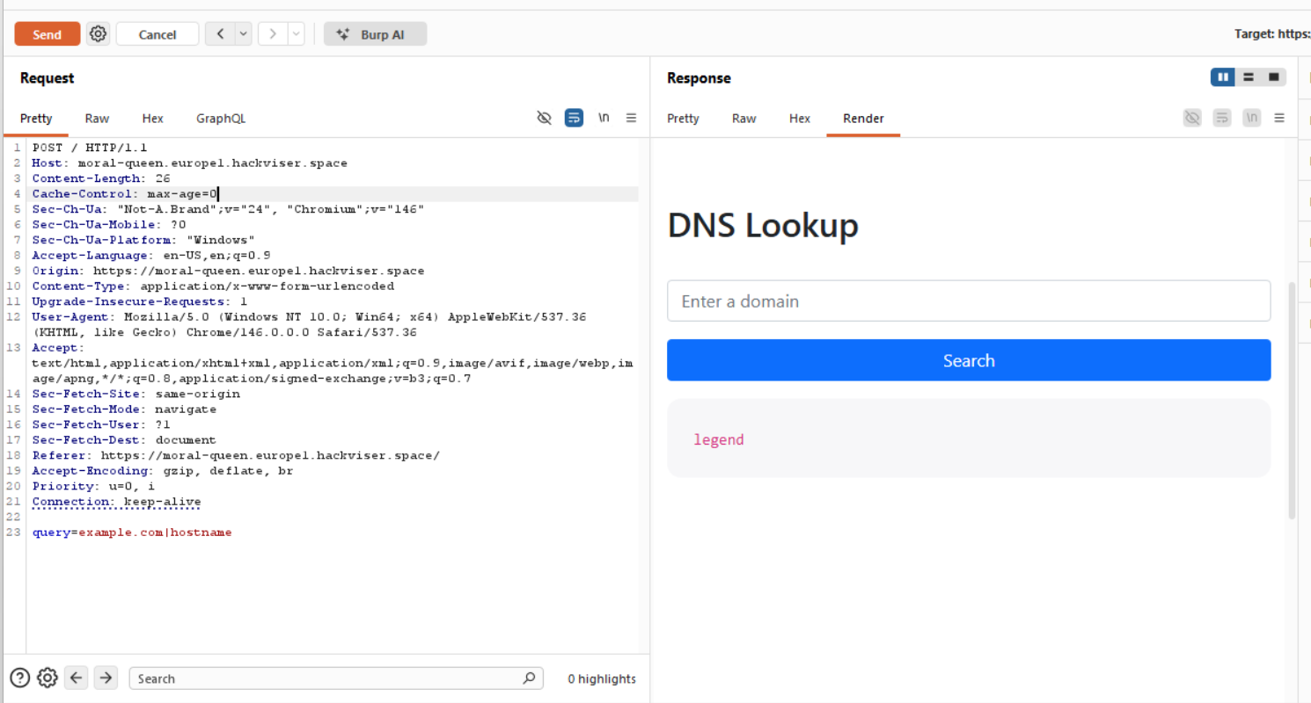
Figure 4: DNS enumeration via injected query
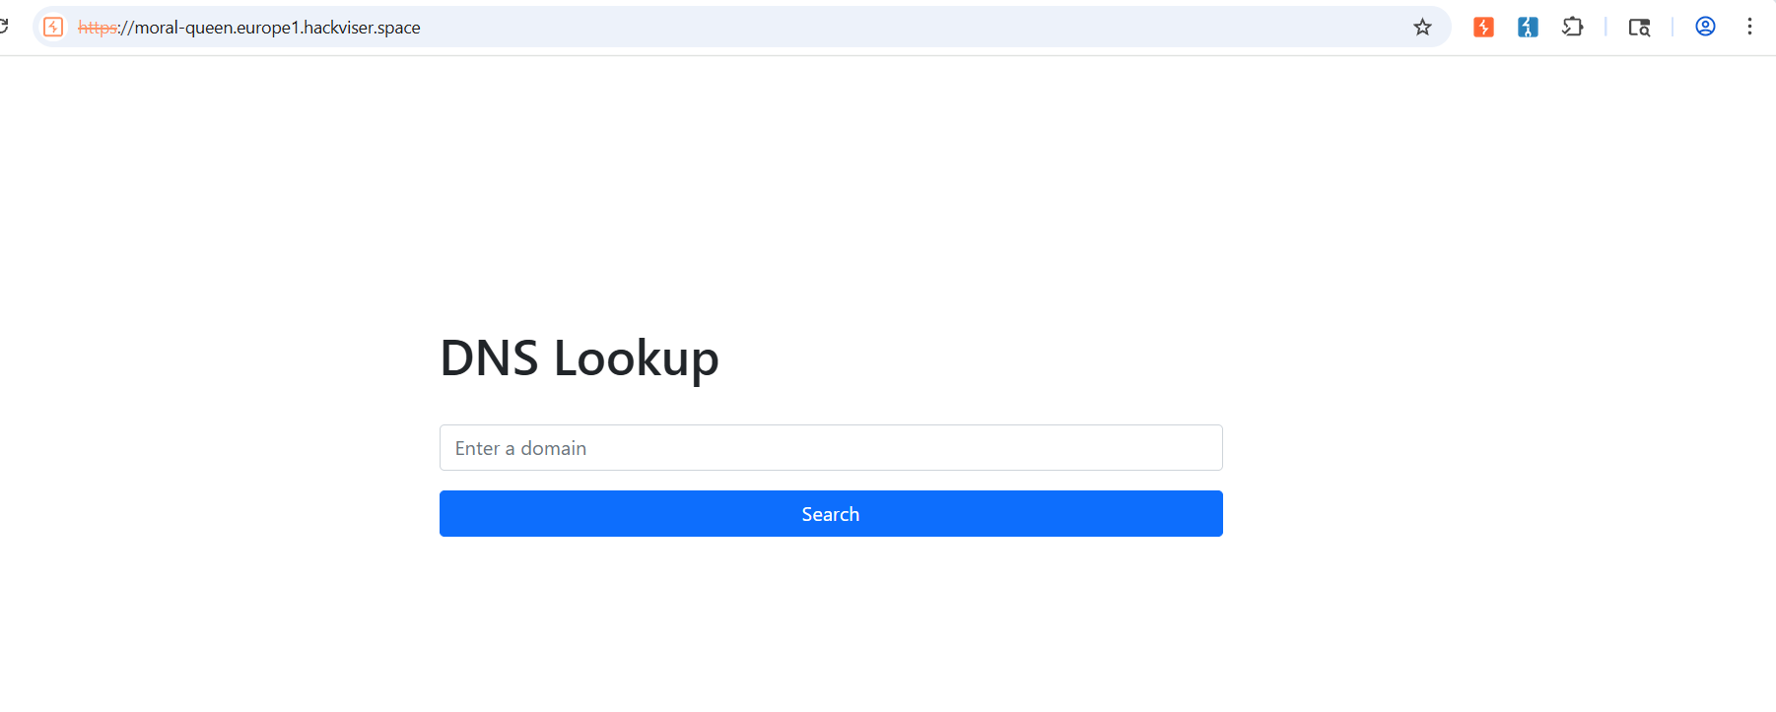
Figure 5: Lab solved — hostname and DNS data exfiltrated
Remediation
Avoid passing user-supplied data to OS commands. Use allowlists for permitted inputs. Implement strict input validation and disable unnecessary system utilities accessible from web context.
Confidential — Prepared by Aakash Singh | Security Research POC

